Sarbottam Piya_London Answers

The average price of houses in a given locality reflects the housing desirability in that locality. **The goal of this project was to identify the London borough that showed the greatest increase in housing prices over the last two decades.** The London boroughs are comprised of 32 local authority districts.

Data for this project was obtained from London Datastore, a free, open-source data-sharing portal. Data analysis were performed using python libraries pandas and numpy and plots were generated using matplotlib.pyplot. Increase in housing prices over the last two decades were determined as the ratio of price in 2020 and 1995.

Based on the analysis, it was observed that Barking & Dagenham, and Kensington & Chelsea were the least and the most expensive boroughs in London in 1995 as well as in 2020. However, our major goal was to identify the London borough that showed greatest increase in housing price over the last two decades; therefore, my conclusion was based on ratio of price in 2020 and 1995. Based on this criterion, it was found that Hackney showed the greatest increase in housing prices over two decades among the 32 London borough. On average, the housing price in Hackney on 2020 is 8.8-fold higher than 1995 (Figure 1).

In this case study, price ratio between 1995 and 2020 was the only criterion that I used to make the decision. It may be worthwhile to check the housing price trend over time for different borough. Furthermore, predicting the future housing price of London borough using this dataset could be an interesting study.

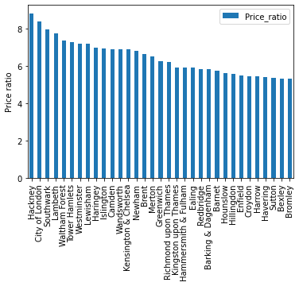

Figure 1. Price ratio of average value in year 2020 to 1995 for London borough houses